**Vehicle Body Control Module**

Main Body control ECU:

/*@!Encoding:

1252

*/

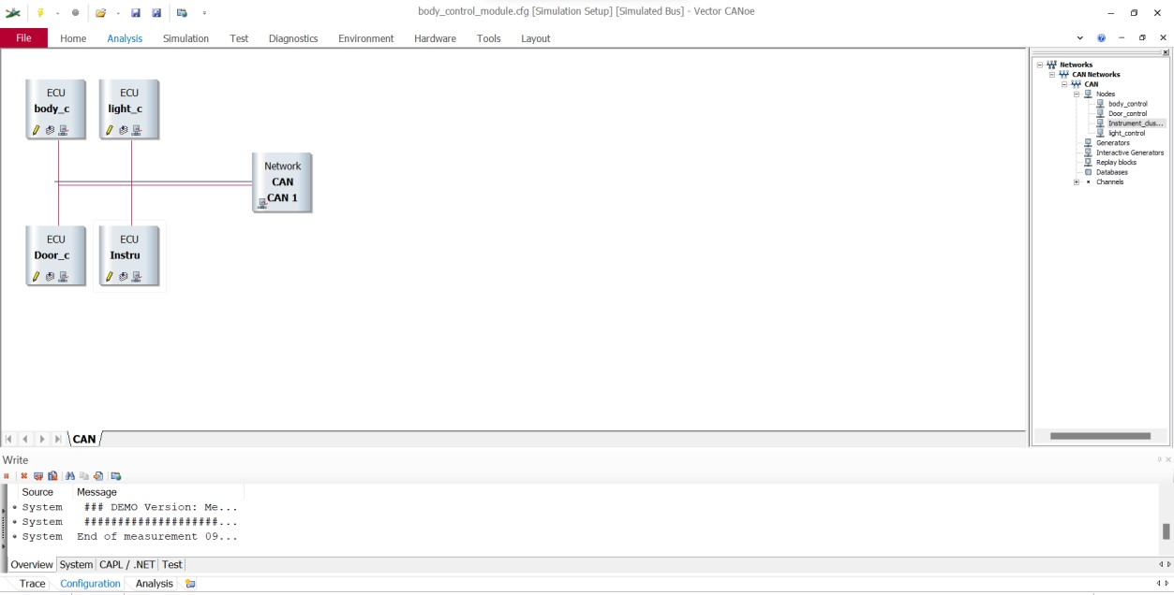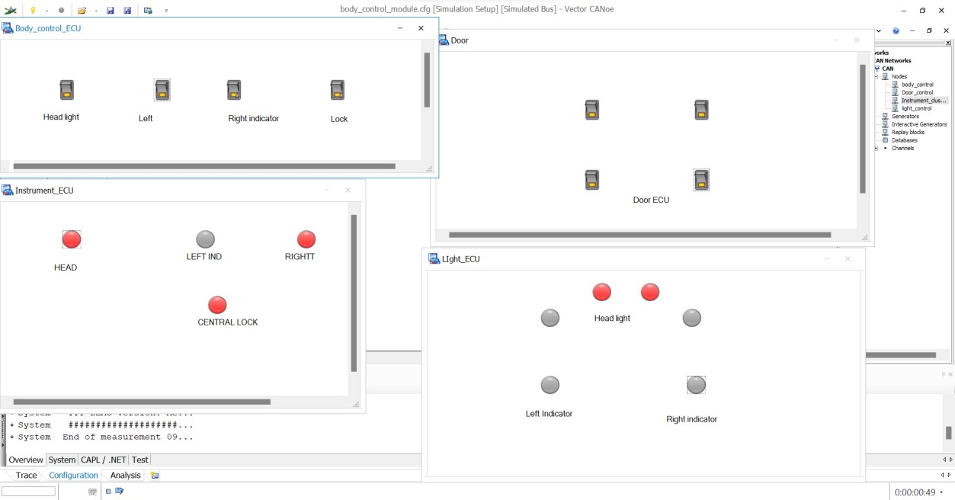

includes

{

}

variables

{

message * m1;//* represent Accept all messages

}

on sysvar `SWITCH::S

{

if(@`SWITCH::S==1)

{ m1.id=0x11; m1.rtr=1; m1.dlc=1; m1.byte(0)=0xA; output(m1);

}

else if(@`SWITCH::S==0)

{

m1.id=0x11; m1.rtr=1; m1.dlc=1; m1.byte(0)=0xBB; output(m1);

}

write("BCM:Central Lock Data Frame Transmitted");

}

on sysvar `SWITCH::S1 //S1 for head light switch

{

if(@`SWITCH::S1==1)

{

m1.id=0x12; m1.rtr=1; m1.dlc=1; m1.byte(0)=0xCC; output(m1);

}

else if(@`SWITCH::S1==0)

{

m1.id=0x12; m1.rtr=1; m1.dlc=1; m1.byte(0)=0xDD; output(m1);

}

write("BCM:Head Light Data Frame Transmitted");

}

on sysvar `SWITCH::SL//Sl Switch left indicator

{

if(@`SWITCH::SL==1)

{

m1.id=0x13; m1.rtr=1; m1.dlc=1; m1.byte(0)=0xEE; output(m1);

}

else if(@`SWITCH::SL==0)

{

m1.id=0x13; m1.rtr=1; m1.dlc=1; m1.byte(0)=0xFF; output(m1);

}

write("BCM:Left Indicator Data Frame Transmitted");

}

on sysvar `SWITCH::SR//SR switch Right indicator

{

if(@`SWITCH::SR==1)

{

m1.id=0x14; m1.rtr=1; m1.dlc=1; m1.byte(0)=0x0A; output(m1); }

else if(@`SWITCH::SR==0)

{

m1.id=0x14; m1.rtr=1; m1.dlc=1; m1.byte(0)=0x0B; output(m1);

}

write("BCM:Right Indicator Data Frame Transmitted");

}

# ******

Light Control ECU:

This ECU consist of indicator(left &right), head light’s

/*@!Encoding:1252*/ includes {

}

variables

{

int f=1;

int fl=1;

msTimer t1; msTimer t2;

}

on timer t1

{

f^=1;

if(f)

{

@`SWITCH::LI=1; }

else

{

@`SWITCH::LI=0; }

setTimer(t1,100);

}

on timer t2 { fl^=1; if(fl)

{

@`SWITCH::RI=1; }

else

{

@`SWITCH::RI=0; }

setTimer(t2,100);

}

on message 0x12 {

if(this.byte(0)==0xCC) {

@`SWITCH::HL=1; }

else if(this.byte(0)==0xDD)

{

@`SWITCH::HL=0; }

write("Head Light Data Recieved in LCM");

}

on message 0x13 {

if(this.byte(0)==0xEE)

{

if(@`SWITCH::SR==1) {

@`SWITCH::SR=0;

@`SWITCH::RI=0;

}

setTimer(t1,100);

}

else if(this.byte(0)==0xFF)

{

cancelTimer(t1);

}

write("Left Indicator Data Recieved ICM");

}

on message 0x14

{

if(this.byte(0)==0x0A)

{

if(@`SWITCH::SL==1)

{

@`SWITCH::SL=0;

@`SWITCH::LI=0;

}

setTimer(t2,100);

}

else if(this.byte(0)==0x0B)

{

cancelTimer(t2);

}

write("Right Indicator Data Recieved ICM");

}

# ******

Door Control Module ECU:

Here all four doors are Controlled via single switch that is nothing but

SWITCH::S

/*@!Encoding:1252*/ includes

{

} variables

{

}

on message 0x11

{ if(this.byte(0)==0xAA)

{

@`SWITCH::L=1;

}

else if(this.byte(0)==0xBB)

{

@`SWITCH::L=0;

}

write("Door Lock Data Received in DCM");

}

# ******

Instrument Cluster ECU:

Here we can know the indications of each action take place

/*@!Encoding:1252*/ includes

{

} variables {

}

on message 0x11 {

if(this.byte(0)==0xAA) {

@`SWITCH::LID=1;

}

else if(this.byte(0)==0xBB)

{

@`SWITCH::LID=0;

}

write("Door Lock Data Recieved ICM");

}

on message 0x12 {

if(this.byte(0)==0xCC) {

@`SWITCH::HID=1;

}

else if(this.byte(0)==0xDD)

{

@`SWITCH::HID=0;

}

write("Head Light Data Recieved ICM");

}

on message 0x13 {

if(this.byte(0)==0xEE) {

@`SWITCH::LEID=1;

}

else if(this.byte(0)==0xFF) {

@`SWITCH::LEID=0;

}

write("Left Indicator Data Recieved ICM");

}

on message 0x14 {

if(this.byte(0)==0x0A) {

@`SWITCH::RID=1;

}

else if(this.byte(0)==0x0B)

{

@`SWITCH::RID=0;

}

write("Right Indicator Data Recieved ICM");

}

# ******

Variable creation:

Environment >> system variable>>

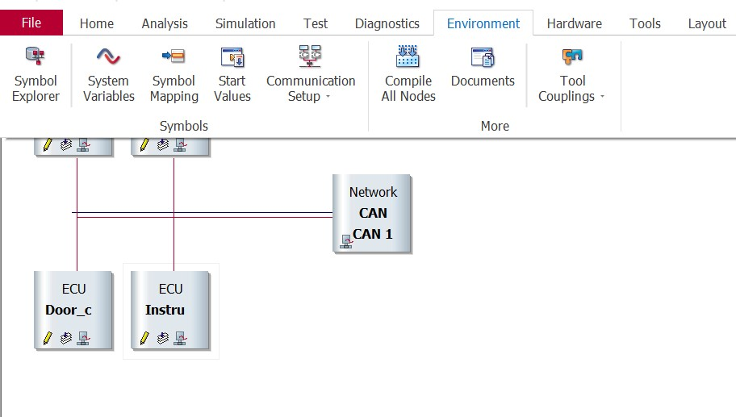

Right click >> new >> namespace

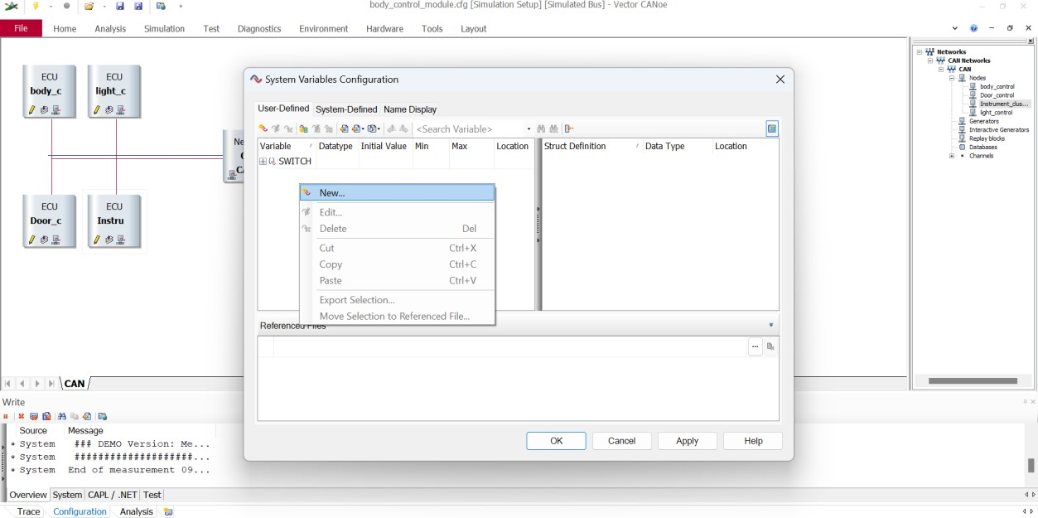

These are the variable involved in this projects

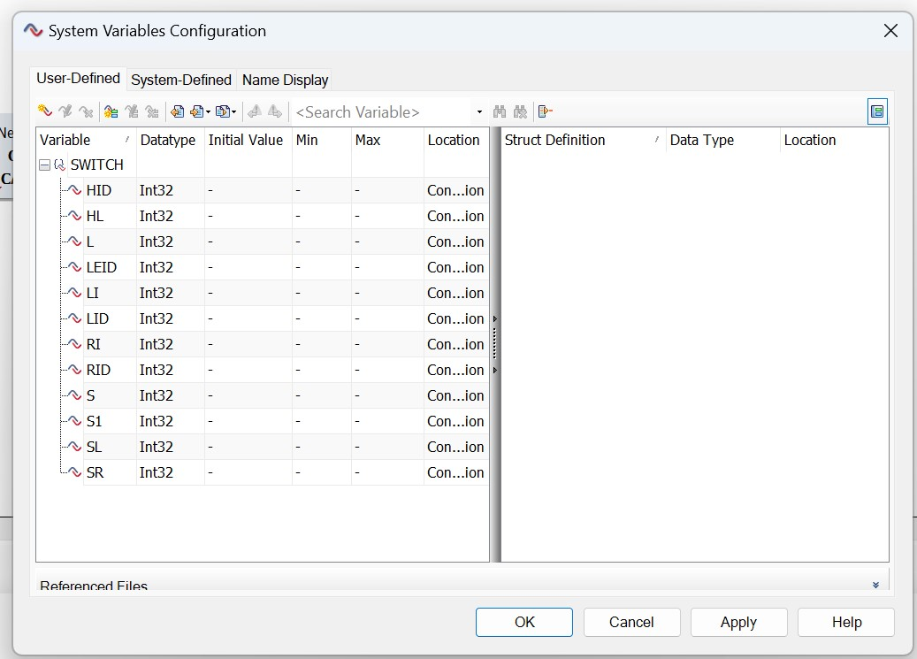

**Thank You…!**